
NAME: ………………………………………………………….
DATE: ……………………………..

Lesson 19
Christmas song
It’s Christmas Eve.
Where is Santa?
Santa, Santa, where are you?
Santa, Santa, where are you?
Are you under the tree?
Are you in your sleigh?
Are you on the rooftop?
Santa, where are you?
Look. Look. Over there.
Look. Look. Over where?
Look. Look. Over there!
Santa, is that you?
No, it’s Daddy.
Santa, Santa, where are you?
Santa, Santa, where are you?
Are you under the tree?
Are you in your sleigh?
Are you on the rooftop?
Santa, where are you?
Look. Look. Over there.
Look. Look. Over where?
Look. Look. Over there!
Santa, is that you?
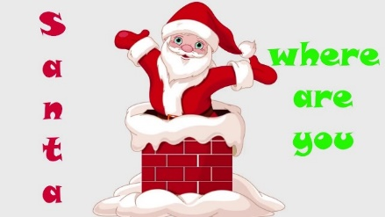
Santa?
Ho ho ho!
Ho ho ho!
Ho ho ho ho ho!
Ho ho ho ho ho!
Ho ho ho ho ho!
Santa!!!

Actividades propuestas para la lección N°19.
Name

Dibuja los conceptos

Santa is under the tree

Santa is on the rooftop

Santa is in his sleigh

Look over there

